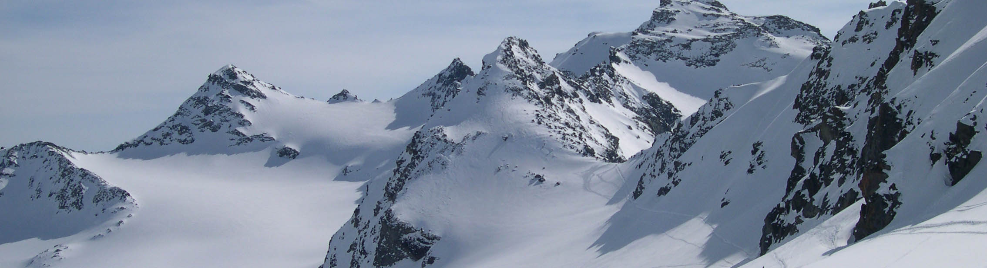
15th All-Russian Scientific Conference with International Participation
“Physics of Ultracold Atoms – 2021”
Organizers: ILP SB RAS, ISP SB RAS, IA&E SB RAS, NSU
20-22 December 2021, Novosibirsk, Akademgorodok, pr. Lavrentieva 15 B,
conference hall of the Institute of Laser Physics SB RAS

Conference website: ultracoldatoms2021.laser.nsc.ru

Dear Colleagues,
We invite you to visit our traditional conference “Physics of Ultracold Atoms – 2021”, which will be held on December 20-22, 2021. Due to the difficult epidemiological situation in Novosibirsk, according to the decision of the program committee, the conference will be held in the format of a video presentation on the Zoom platform. The conference is an annual scientific forum aimed at discussing new theoretical and experimental results in the field of laser cooling of atoms and ions, optical frequency standards, ultracold Bose and Fermi gases, nonlinear laser spectroscopy and quantum informatics. Online oral reports will be presented at the conference. The official languages are Russian and English. The sessions will be organized by the Institute of Laser Physics SB RAS (ILP SB RAS, www.laser.nsc.ru).
Other conditions of participation and the conference rules remain the same: no registration fee is required; duration of oral presentations is limited to 30 minutes (including questions and answers).
If you plan to participate, please send until 12 December 2021 by e-mail ultracoldatoms2021@mail.ru the attached registration form with the author names, the preliminary title of your report and the information about each conference participant from your organization.
We are waiting for you at the conference!

Conference program committee:
Taichenachev Alexey Vladimirovich, chairman, ILP SB RAS, taichenachev@laser.nsc.ru,
tel. +7-913-719-42-84
Ryabtsev Igor Ilyich, ISP SB RAS, ryabtsev@isp.nsc.ru
Chapovsky Pavel Lvovich, IA&E SB RAS, chapovsky@iae.nsk.su
Beterov Ilya Igorevich, ISP SB RAS, NSU, beterov@isp.nsc.ru

Conference secretary:
Basalaev Maksim Yurevich, ILP SB RAS, mbasalaev@gmail.com, tel. +7-923-248-64-21

